**Ideation Phase**

**Define the Problem Statements**

|  |  |
| --- | --- |
| Date | 29 April,2023 |
| Team ID | NM2023TMID06584 |
| Project Name | A Reliable Energy Consumption Analysis System for Energy Efficient Applications |
| Maximum Marks | 2 Marks |

**Customer Problem Statement Template:**

Create a problem statement to understand your customer's point of view. The Customer Problem Statement template helps you focus on what matters to create experiences people will love.

The lack of a reliable energy consumption analysis system for energy-efficient appliances hinders accurate assessment and optimization of energy usage in households and commercially.Graphical user interface, text, application, email

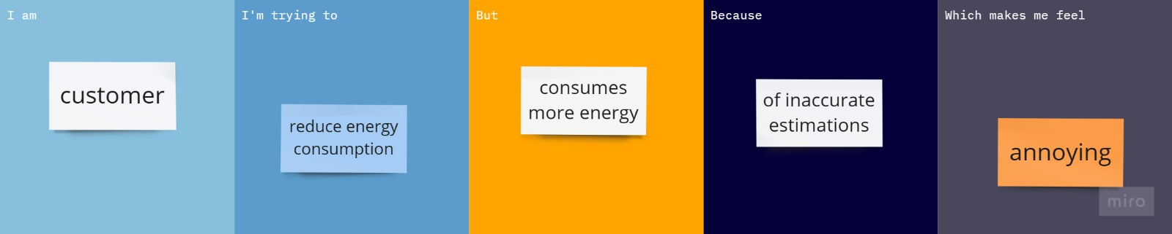

|  |  |  |  |  |  |
| --- | --- | --- | --- | --- | --- |
| **Problem Statement (PS)** | **I am (Customer)** | **I’m trying to** | **But** | **Because** | **Which makes me feel** |
| PS-1 | customer | Reduce energy consumption | Consumes more energy | Of inaccurate estimations | annoying |
| PS-2 | customer | Optimize the energy | Limits the ability of usage | Of low power mode | frustrated |